24‑HOUR SELF‑DRIVE COBRA EXPERIENCE
Collect 08:30 • Return Next Day 08:30
Experience Cape Town on your own schedule with our 24‑hour Cobra rental — the perfect blend of freedom, style, and classic motoring excitement.
Please arrive 30 minutes early for paperwork, a safety briefing, and a full orientation on your Cobra.
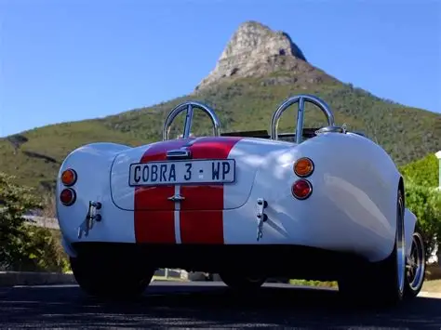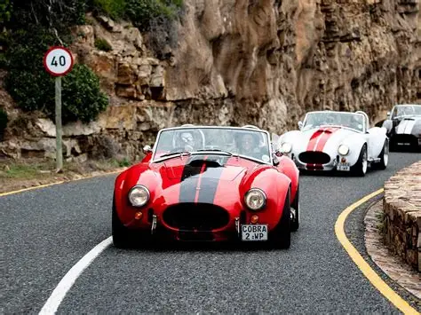
ACTIVITY DESCRIPTION
Since Carroll Shelby introduced the first Cobra in 1962, this iconic machine has captured the imagination of drivers worldwide. If touring the Cape Peninsula in a bus or standard rental car doesn’t excite you, elevate your adventure — drive a Cobra and make the journey part of the experience.
Not sure where to go?
We’ll help you plan the perfect route and load your personalised itinerary directly onto your smartphone or GPS at pick‑up.
This popular 24‑hour option allows you to explore Cape Point and all the top highlights at your own pace. Enjoy legendary roads and scenic stops including:
Chapman’s Peak (route excluded for safety)
- Scarborough Beach
- Boulders Beach Penguins
- Cape Point
VEHICLE DETAILS
- Class: Modern Classic
- Doors: 2
- Seats: 2
- Fuel: Petrol
- Gearbox: Automatic
- Engine: V8
- FACTORY BUILT | V8 | AUTOMATIC | POWER STEERING | MODERN BRAKES
ARRANGEMENTS
- When: All year round
- Where: Foreshore, Cape Town, 8001
- Weather: Operates in safe weather conditions
- What to Wear: Comfortable clothing, closed shoes, warm jacket
- Things to Bring: Driver’s license, credit card for deposit, cash for toll roads
REQUIREMENTS
- Minimum Age: 23 years
- Qualifications: Valid driver’s license
Guests: One free passenger included

INCLUSIONS & EXCLUSIONS
Inclusion:
- Pick up at hotel
- Drop off at site
- 130 km free mileage
- Pick up at site
- Drop off at hotel
Exclusions:
- Fuel
- Additional mileage at R20.00 per km
Travel via Chapman’s Peak Drive (Noordhoek → Hout Bay) — excluded due to safety restrictions
NOTES
- R6400 Self Drive
- Rental Duration: 08:30 – 08:30 (24 hours)
- Fuel must be replenished on return
- Extra driver fee: R500
- Mileage over 130 km: R20.00 per km
SECURITY & LIABILITY HOLDING FEE
R15,000 security deposit (card pre‑authorisation)
This temporary holding fee covers insurance excess, vehicle damage, traffic fines, recovery costs, or breaches of the rental agreement. Any unused portion is released after inspection and fine clearance.

Cash deposit: R20,000 or $1200
Cash deposits for sunset/sundowner hires may only be returned from 08:30 the following day.

T’s & C’s apply.

